

HOTEL MANAGEMENT SYSTEM
Future of Automated Systems…

Muhammad Obaid-Ur-Rehman (43107)
Omema Javed (43310)
S.M Mutahar Jamal (43515)
Muzzamil Ehsan Faheem(41917)

Client: S.M Mutahar Jamal (43515)

Submitted To: Dr. Ebrahim Mansoor
Project Proposal

Section – 1

1.1 Project Identification
Project Title:
Hotel Management System

Group Leader (GL):
1. | Name: | Omema Javed
 | Reg #: | 43310
 | CGPA: | 2.4
 | Mobile # : | 03460135830 | Email: |  | Ummejaved22@gmail.com
 | Signature:
Group Members (GM’s):
2. | Name: | M.Obaid ur Rehman
 | Reg #: | 43107
 | CGPA: | 2.86
 | Mobile # : | 03112720622 |  | Email: |  | Obaid_bss@live.com
 | Signature:
3. | Name: | S.M.Mutahar Jamal
 | Reg #: | 43515
 | CGPA: | 2.23
 | Mobile # : | 03352133887 |  | Email: |  | Mutaharjamal7@gmail.com
 | Signature:

4. | Name: | Muzzammil Ehsan Faheem
 | Reg #: | 41917
 | CGPA: | 2.5
 | Mobile # : | 03022379694 | Email: | Muzziehsan17@gmail.com
 | Signature:

What technology is core to your product?
[ ] 3D/4D Printing |  | [ ] Augmented Reality / Virtual Reality
[ ] Big Data, Artificial Intelligence |  | [ ] Blockchain
[ ] Cloud |  | [ ] Neurotech
[ ] Robotics |  | [ ] Shared economy
[ ] The Internet of Things |  | [ ] Wearables, Implantables
[✓] Others (specify): | Intranet System

What is the target market(s) for the products?
[ ] Automotive, aviation, marine |  | [ ] Business, marketing, finance
[ ] Defence, security, safety |  | [ ] Education and training
[ ] Environment, water management |  | [ ] Entertainment, tourism, sport/recreation
[ ] Food, livestock, agribusiness |  | [ ] Healthcare
[ ] Infrastructure, housing & transport |  | [ ] Mining equipment technology & services
[ ] Oil, gas, energy |  | [ ] Textiles, clothing, footwear
[✓] Others (specify): | Hotels, Restaurants

Other Organizations Involved in the Project:
Academic Organizations:
# | Organization Name |  |  | Role / Contribution
Industrial Organizations:
# | Organization Name |  | Role / Contribution
Funding Organizations:
# | Organization Name |  |  | Role / Contribution
Key Words:
Automation, Administration
Project Status: (Please mark ☑)
[✓] New [ ] Modification to previous Project
[ ] Extension of existing project

Project Duration: |  | Two Months
Proposed Budget: |  | 20 Thousands
Project Description:
Hotels and Restaurants in Pakistan extensively use book keeping for their operations. HMS will help hotels to automate their system, which will include everything from reservation to checking availability of rooms/tables/inventory. Administration panel will help supervisors to manage inventory.

Project Justification:
A state of the art solution for better management of hotels and restaurants with an aim to make this software the market leader in all leading hotels in Pakistan.

We will use the following techniques/tools to achieve the final product.

Environment:
We have decided to make our system windows based, we will not be supporting any other environment like Mac, Linux etc. the reason for this that most of the people are familiar with windows based systems .

Platform:
The system will be a desktop application since most of the clients we had a discussion with were already using desktop-based system.

Technology:

Software will be build using windows forms and C# as the programming language. .NET framework version 4.5 or later will be used.

We will be utilizing rich form controls for best user experience and more functionality such that
Data grids, Combos etc.

For database, we will be using Microsoft SQL server because of better compatibility with .NET applications.

IDE:
For development purpose, we will be using Visual studio 2019.

Synopsis:
Management
Product benefit:
Our system would benefit small to medium sized hotels and Restaurants to compete with market leaders at an economical prize. We will routinely evolved the product based on market and clients need and it would be helpful for businesses to grow by cutting down the cost of manual processing

Target Market :
Small to medium sized hotels and restaurants to full fill their basic operation needs and automate their processes

Commercial Partner:
In future, we planned to enhance our product in a way that we will support advertisement from vendors and related parties that do business with our hotel client. This will enable us and our clients to generate more funds.

Investor:
We also planned to approach few investors to support our product in a business model that will benefit both of us.

Potential clients:
since it’s a research based project we do not have any actual client at the moment we will be providing demos

Section – 2

2.1 Background
Scope of the Project:
This project will cover the fowling areas:

Administration panel:

- Addition of rooms and table
- Modification of room and table
- Addition of inventory items
- Modification of inventory items

Supervisor Panel:
- Reservation for rooms and tables
- Check availability of rooms and tables

Challenges:
Protection of data: We need to make sure that the data of customers will not leak or hacked. We can achieve this by putting some encryption.

Security: Insecurity, we also need to make sure that data is not hacked. We have to make our system secure that no one can attack our policy. We will secure it by installing a firewall.

User acceptability: Clients are satisfied from old policies because old policies looks easy in use to the client. Client do not easily shift to the new policies because there is a training which hesitate the client.

Competition: Market competition is quit difficult Its not easy to survive in market as Big players already have hotel management systems. They implement their work by researching according to the client’s need in the market.

Data Migration: The migration of old data from the old system to the new policy. We do not need to change the schema of the database because it can produce trouble, so we just modified the front end of the database and we migrate the data by using some API.

Motivation and Need:
Entry-point Solution:
We will be providing an entry point solution for small and medium scale businesses that are ready to adapt new solutions. This is a window of opportunity as larger entities will not be willing to take the risk of implementing new softwares.

Economical Option:
Our product will be an economical alternative to more expensive and high-end solutions that small business cannot afford. This will provide us an edge to penetrate the lower-end market

Customization:
We will be adapting an agile approach and will updating our system based on client feedback. This will enable our customers to get involved with us on a developmental level and get features they want. It will attract more and more customers as they get customizable solutions.

User-friendly:
Our product would have a user-friendly interface that would be easy for new customers to adapt. User experience would be our top priority.

2.2 Outcomes and Benefits
Expected Outcomes:
- The anticipated result of this project includes a benchmark for these type of automated applications and will provide save payment method after the completion of task.

- At one restaurants will get so user-friendly system.

- The system will work faster and faster with later upgrades

Key Benefits and Beneficiaries:
- Small to Medium Scale Hotels/Restaurants
- Investors and Partners that fund our project
- Vendors who want to advertise on our system

2.3 Objectives
- Provide a rational & strong platform to every restaurants in town.
- To develop a system that automates hotel operational processes
- To get feedback from customers and implement those changes
- Provide a smart and easy way to do every day work easy.

Key Milestones and Deliverables:
S. No. | Elapsed time since start of the project | Milestone | Deliverable
1. | Week 01 | Project Plan Features & Functionalities | Project Idea Finalization.
2. | Week 02-03 | Project Initial Research | Project & Feature Related Discussion
3. | Week 04-05 | ERD & Related Diagrams | System Diagrams
5. | Week 06-07 | Prototype Development (GUI+MODEL) | Project Working & Discussion
4. | Week 08 | Supervisor Panel | Supervisor Panel (beta) for testing
3. | Week 09 | Admin Panel | Admin Panel (beta) for testing
11. | Week 10-11 | UI Design & Application maintenance | Overall Maintenance
12. | Week 12 | A complete working Application | Project Completion

Section – 3

3.1 Resources & Other Requirements
Project Team:
The numbers in the table below must tally with the HR Cost sheet in the Budget file.
Title / Position | Number
Team Leads | 1
Researchers / Developers | 2
Researcher / Development Assistants | 1
Support Staff | 1
Contract Staff (please specify) | -
Others (please specify) | -
Team Structure:

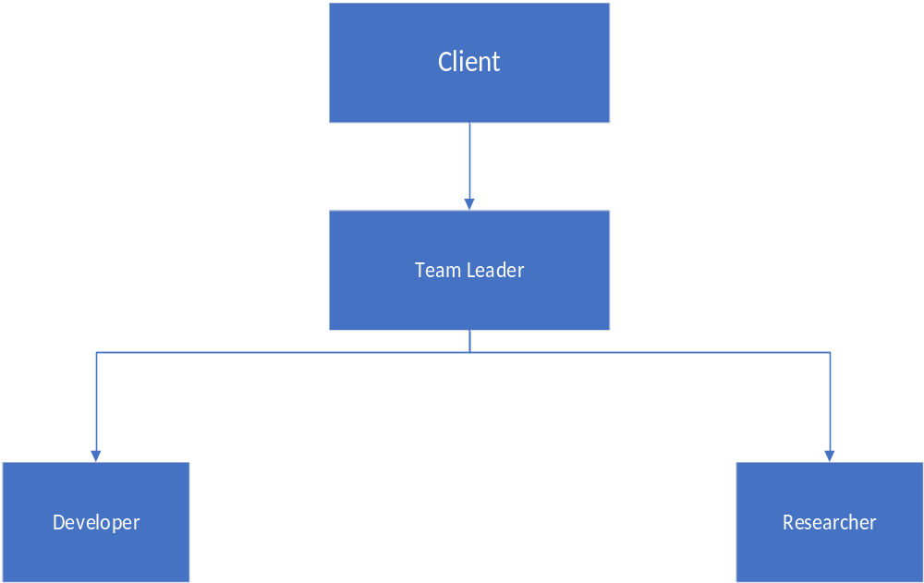

Title/Position  (of each member) | Role/Key Responsibilities | Minimum Qualification Required | Expertise / Background Required | Minimum Experience Required (years)
Team Leader | Work, Major Development. Architecture Design, manage & assign tasks to every individual member. | BS(CS) | Synced in development environment / Technology & Management skill sets of Auditing the code and keep on maintaining the quality work. | 2.5years
Developers | Research & Design of hybrid application | BS(CS) | Good grasp on technology stack. | 1year
Researchers | Research & Contribute in Development | BS(CS) | Good RnD skillsets | 6months

Remarks:

1. Name & Signature of client:

2. Name & Signature of Faculty:

